Ending your Shift (Going Home)
Step 1 – Swipe your Card over the Card Reader
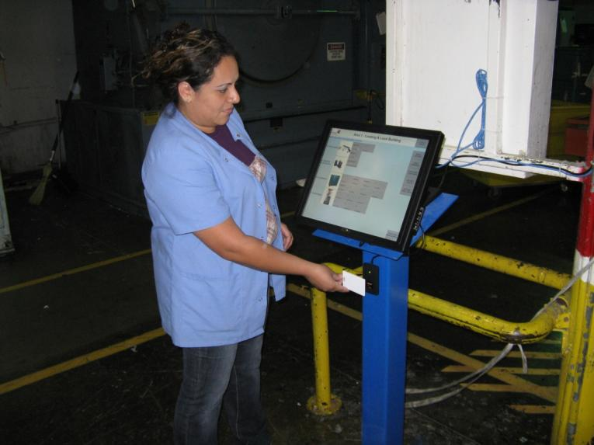

Your name will show with your current status
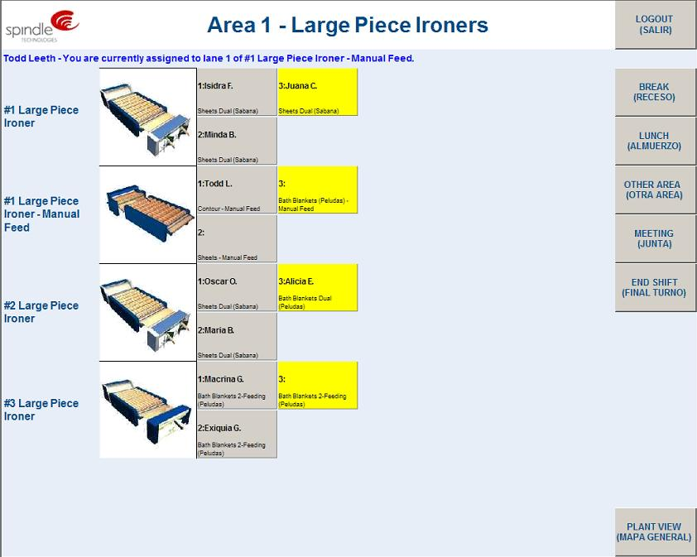
Step 2 – Select End Shift
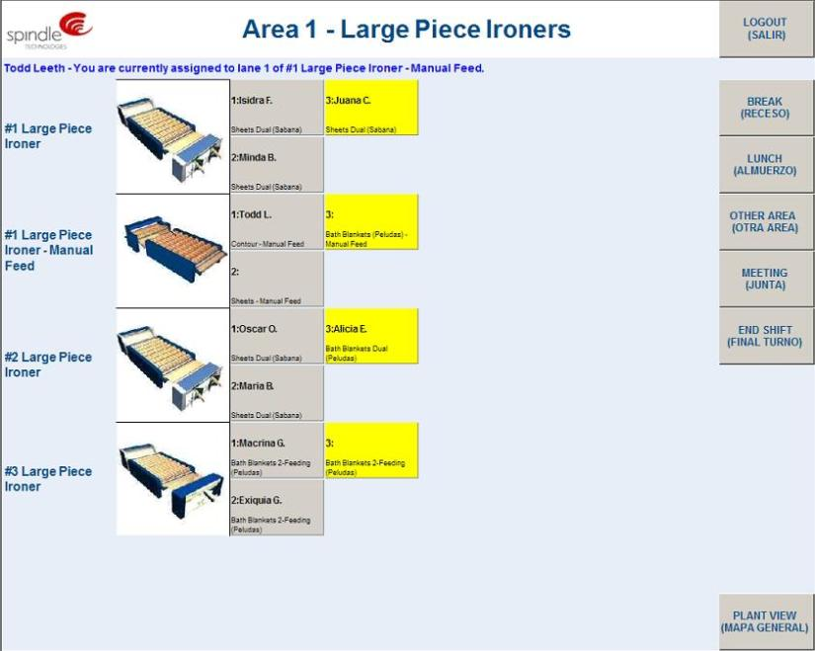

Your name will be removed and you are out of system
